**Gannarapu pavan Kumar**

**916217**

**Stage-3 Day-68 Angular Hands-on-1**

**Define JavaScript object for employee**

**Employee.js:**

var firstname;

var lastname;

var salary;

var permenantstaff;

function employee(fname, lname, salary, permenantstaff) {

    this.firstname = fname;

    this.lastname - lname;

    this.salary = salary;

    this.permenantstaff = permenantstaff;

}

var empobj = new employee("John", "Stoke", 5000, true);

console.log('First Name:' + firstname + '\n' + "Last Name:" + lastname);

**employee.html**

<!DOCTYPE html>

<html lang="en">

<head>

    <meta charset="UTF-8">

    <meta http-equiv="X-UA-Compatible" content="IE=edge">

    <meta name="viewport" content="width=device-width, initial-scale=1.0">

    <title>Document</title>

</head>

<script>

    var firstname;

var lastname;

var salary;

var permenantstaff;

function employee(fname, lname, salary, permenantstaff) {

    this.firstname = fname;

    this.lastname = lname;

    this.salary = salary;

    this.permenantstaff = permenantstaff;

}

var empobj = new employee("John", "Stoke", 5000, true);

console.log(empobj);

</script>

<body>

</body>

</html>

**Output:**

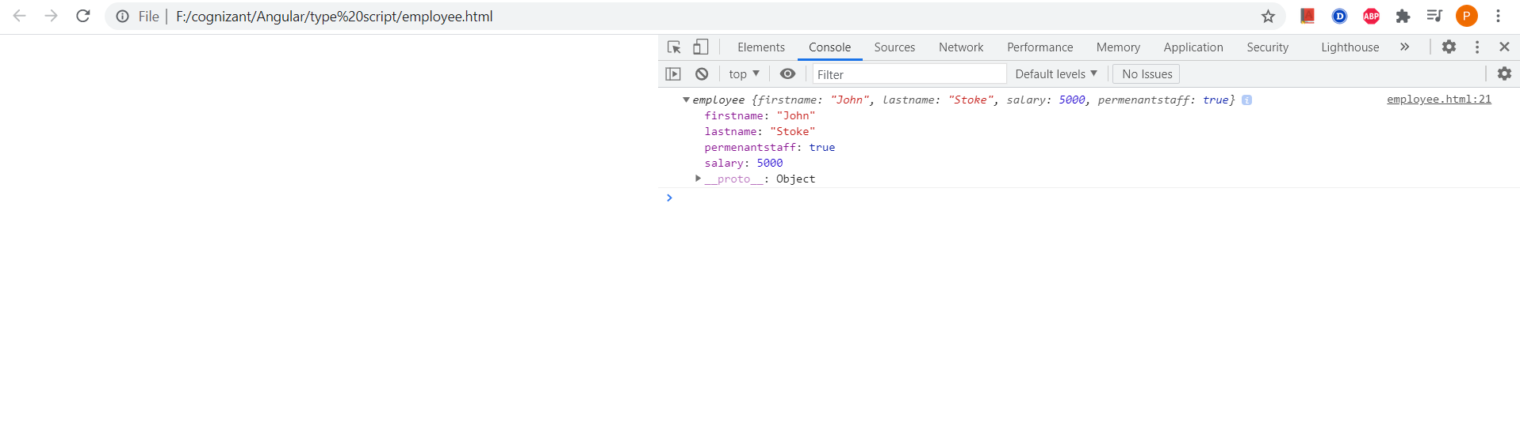

**Define JSON for employee details and parse**

**Json file**

const text = '{"fname":"John", "lname":"Stoke", "salary":5000,"pstaff":true}';

const obj = JSON.parse(text);

console.log("First Name:"+obj.fname);

console.log("Last Name:"+obj.lname);

console.log("Salary:"+obj.salary);

console.log("Permenant Staff:"+obj.pstaff);

**employee.html**

<!DOCTYPE html>

<html lang="en">

<head>

    <meta charset="UTF-8">

    <meta http-equiv="X-UA-Compatible" content="IE=edge">

    <meta name="viewport" content="width=device-width, initial-scale=1.0">

    <title>Document</title>

</head>

<script>

const text = '{"fname":"John", "lname":"Stoke", "salary":5000,"pstaff":true}';

const obj = JSON.parse(text);

console.log("First Name:"+obj.fname);

console.log("Last Name:"+obj.lname);

console.log("Salary:"+obj.salary);

console.log("Permenant Staff:"+obj.pstaff);

</script>

<body>

</body>

</html>

**Output:**

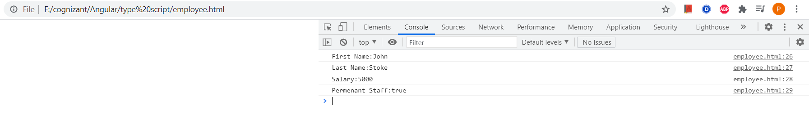

**Add department details to employee**

**Json file:**

const text = '{"fname":"John", "lname":"Stoke", "salary":5000,"pstaff":true,"deptid":4,"deptname":"tax"}';

const obj = JSON.parse(text);

obj.deptid=3;

obj.deptname="Payroll";

console.log("First Name:"+obj.fname);

console.log("Last Name:"+obj.lname);

console.log("Salary:"+obj.salary);

console.log("Permenant Staff:"+obj.pstaff);

console.log("Department Id:"+obj.deptid);

console.log("Department Namae:"+obj.deptname);

**employee.html**

<!DOCTYPE html>

<html lang="en">

<head>

    <meta charset="UTF-8">

    <meta http-equiv="X-UA-Compatible" content="IE=edge">

    <meta name="viewport" content="width=device-width, initial-scale=1.0">

    <title>Document</title>

</head>

<script>

const text = '{"fname":"John", "lname":"Stoke", "salary":5000,"pstaff":true,"deptid":4,"deptname":"tax"}';

const obj = JSON.parse(text);

obj.deptid=3;

obj.deptname="Payroll";

console.log("First Name:"+obj.fname);

console.log("Last Name:"+obj.lname);

console.log("Salary:"+obj.salary);

console.log("Permenant Staff:"+obj.pstaff);

console.log("Department Id:"+obj.deptid);

console.log("Department Namae:"+obj.deptname);

</script>

<body>

</body>

</html>

**Output:**

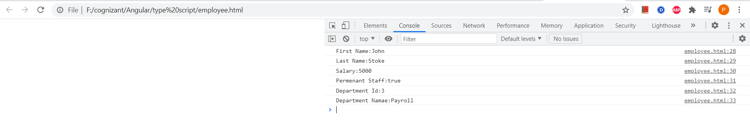

**JSON - Add skill details to employee**

<script>

const text = '{"fname":"John", "lname":"Stoke", "salary":5000,"pstaff":true,"deptid":4,"deptname":"tax","skills":[{"id":"1", "value":"HTML"},{"id":"2", "value":"CSS"},{"id":"2", "value":"Javascript"}]}';

const obj = JSON.parse(text);

obj.deptid=3;

obj.deptname="Payroll";

console.log("First Name:"+obj.fname);

console.log("Last Name:"+obj.lname);

console.log("Salary:"+obj.salary);

console.log("Permenant Staff:"+obj.pstaff);

console.log("Department Id:"+obj.deptid);

console.log("Department Namae:"+obj.deptname);

for(var i=0;i<obj.skills.length;i++){

console.log("Skill "+(i+1)+":"+obj.skills[i].id+", "+obj.skills[i].value)

}

</script>

**Output:**

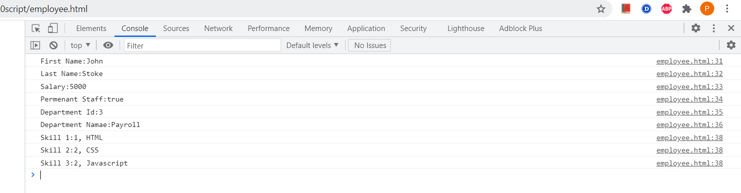

**Session2**

**Include Department details in Employee and display**

**Employee.ts**

export interface employee {

    id:number;

    name:string;

    salary:number;

    permanent:boolean;

    departmentid:number

    }

**Employee_test.ts:**

import {employee} from  './employee'

var emp:employee = {

    id:3,

    name:"John",

    salary:5000,

    permanent:true,

    departmentid:1,

    }

    console.log("id : "+emp.id);

    console.log("name : "+emp.name);

    console.log("salary : "+emp.salary);

    console.log("permanent : "+emp.permanent);

    console.log("Department Id : "+emp.departmentid);

**employee.html**

<!DOCTYPE html>

<html lang="en">

<head>

    <meta charset="UTF-8">

    <meta http-equiv="X-UA-Compatible" content="IE=edge">

    <meta name="viewport" content="width=device-width, initial-scale=1.0">

    <title>Document</title>

<script>

var emp = {

    id: 3,

    name: "John",

    salary: 5000,

    permanent: true,

    departmentid: 1,

    departmentname: "Payroll"

};

console.log("id : " + emp.id);

console.log("name : " + emp.name);

console.log("salary : " + emp.salary);

console.log("permanent : " + emp.permanent);

console.log("Department Id : " + emp.departmentid);

</script>

<body>

</body>

</html>

**output:**

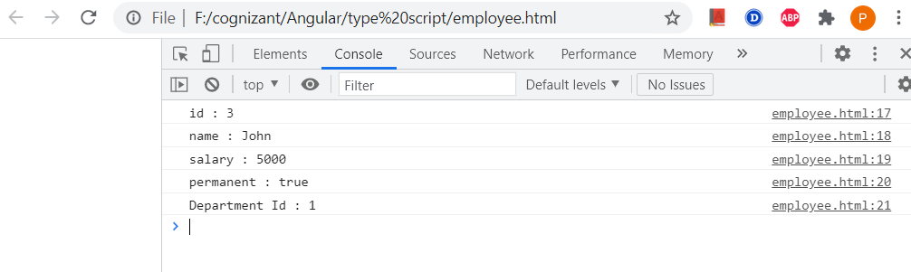

**employee.ts**

import { Department } from './Department';

export class Employee implements Department{

id:number;

name:string;

salary:number;

permanent:boolean;

constructor(id:number, name:string, salary:number, permanent:boolean){

this.id = id;

this.name = name;

this.salary = salary;

this.permanent = permanent;

}

}

**Department.ts**

export interface Department{

    id:number;

    name:string;

    }

**employee-test.ts**

import {Employee} from  './Employee'

import { Department } from './Department';

var emp:Employee = {

    id:3,

    name:"John",

    salary:5000,

    permanent:true,

    departmentid:1,

    departmentname:"Payroll"

    }

    console.log("id : "+emp.id);

    console.log("name : "+emp.name);

    console.log("salary : "+emp.salary);

    console.log("permanent : "+emp.permanent);

var dept:Department = {

id:1,

name:"Payroll",

}

    console.log("Department Id : "+emp.departmentid);

    console.log("Department Name : "+emp.departmentname);

**employee.html**

<!DOCTYPE html>

<html lang="en">

<head>

    <meta charset="UTF-8">

    <meta http-equiv="X-UA-Compatible" content="IE=edge">

    <meta name="viewport" content="width=device-width, initial-scale=1.0">

    <title>Document</title>

<script>

var emp = {

    id: 3,

    name: "John",

    salary: 5000,

    permanent: true,

    departmentid: 1,

    departmentname: "Payroll"

};

console.log("id : " + emp.id);

console.log("name : " + emp.name);

console.log("salary : " + emp.salary);

console.log("permanent : " + emp.permanent);

console.log("Department Id : " + emp.departmentid);

console.log("Department Name : " + emp.departmentname);

</script>

<body>

</body>

</html>

**Output**

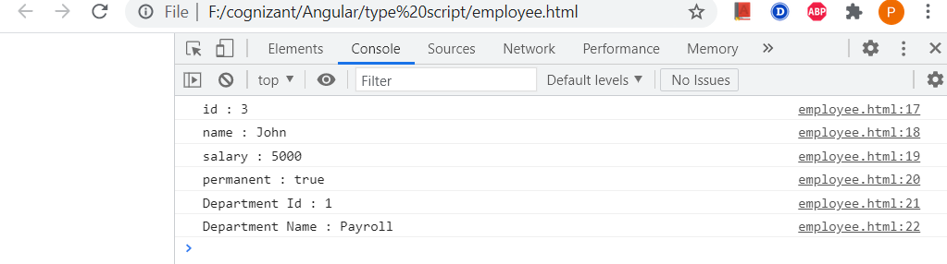

**TypeScript data types and interface – Include Skill details in Employee and display**

**skill.ts**

export interface Skill{

    id:number;

    name:string;

    }

**employee.ts**

import { Employee } from './Employee';

import { Skill } from './Skill';

import { Department } from './Department';

var emp1 = new Employee(123, "John", 10000, true);

console.log("id: "+emp1.id);

console.log("name: "+emp1.name);

console.log("salary: "+emp1.salary);

console.log("permanent: "+emp1.permanent);

var dept:Department = {

    id:1,

    name:"Payroll",

    }

console.log("Department id : "+dept.id);

console.log("Department name : "+dept.name);

var skill1:Skill = {

    id:1,

    name:"HTML",

    }

var skill2:Skill = {

    id:2,

    name:"CSS",

    }

var skill3:Skill = {

    id:3,

    name:"JavaScript",

    }

console.log("Skill[0]:"+skill1.id+", "+skill1.name);

console.log("Skill[1]:"+skill2.id+", "+skill2.name);

console.log("Skill[2]:"+skill3.id+", "+skill3.name);

**Employee-test.ts**

import { Employee } from './Employee';

var emp1 = new Employee(1, "HTML");

var emp2 = new Employee(2, "CSS");

var emp3 = new Employee(3, "Javascript");

console.log("Skill 1: "+emp1.id+", "+emp1.name);

console.log("Skill 2: "+emp2.id+", "+emp2.name);

console.log("Skill 3: "+emp3.id+", "+emp3.name);

**output:**

